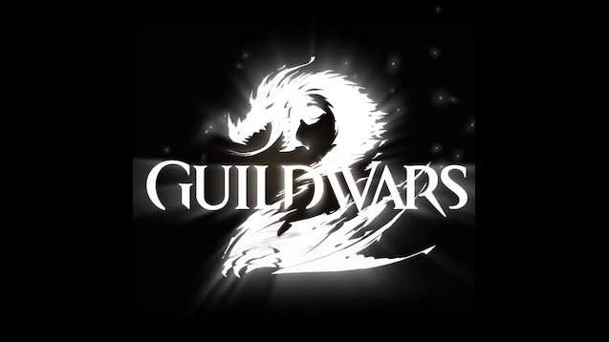

GUILDWARS 2 Storms of Winter Guide

Storms of Winter meta all useful things need to know about the event.

By Leksa Km Trikru AKA Larissa

Guardian of the united[gotu] (Leader)  EU based

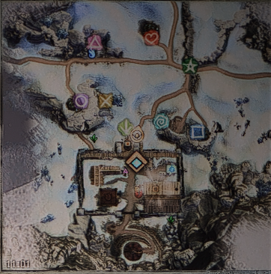Storms Of Winter

Marked places see here

Arrow = hammer box for first phase

Circle, quad, heart = shrines

Triangle, star, spiral, cross = portals that spawn in the 2nd phase

----------------------------------------------------------------------------------------------------------------------

PHASE 1 🡪 all pick a hammer from the box at the arrow mark and build all stuff

----------------------------------------------------------------------------------------------------------------------

PHASE 2 🡪 (don’t forget to drop hammer) split up between shrines and a small group (preferable together with the one leading) goes for the portals. Those at the shrines focus on the bombers that come walking towards the shrines. The bombers take priority for those at the shrines since the bombs damage the shrines much. The adds will be taken care of by the small portal group. The event is timer bound so you cannot speed it up  
  
PS: the portals can start bugging if you kill them fast meaning portals wont activate and you get only the bombers to focus on keep an eye out on portals in event window those since sometimes 1 reopens out of nowhere after many minutes

----------------------------------------------------------------------------------------------------------------------

PHASE 3 🡪 don’t stand on the shrines when the timer of defending shrines has run out it will cause ppl to die. If the shrines covered in ice stack on the shrine and attack the ice only with as much Aoe ,DPS etc as possible. This way you take also the adds down same time. Next thing you do is take out the 3 ballista’s near each shrine.

----------------------------------------------------------------------------------------------------------------------

PHASE 4 🡪 as commander walk towards the big tower you see behind the middle shrine. There the ice giant will spawn let some ppl man chains and stick on the giant with rest of the squad (keep stacking so no one gets frozen either) DPS the giant

PHASE 5 🡪 go to Asgeir’s Legacy. Let them stick at tag (or tag tells them to pick champion after champion together and he will mark chests + raven portal that includes 3 chests inside) all champs dead? That was the whole event